TEST PROGRAMS:

METHOD OVERRIDING:

#include<iostream>

using namespace std;

class person

{

public:

string name,gender;

int age;

void setdata()

{

cout<<"enter name\n";

cin>>name;

cout<<"enter gender\n";

cin>>gender;

cout<<"enter age\n";

cin>>age;

}

virtual void work()

{

cout<<"name:"<<name<<endl;

cout<<"age:"<<age<<endl;

cout<<"gender:"<<gender<<endl;

}

};

class employee:public person

{

public:

string specialist;

int sal;

void setdata1()

{

cout<<"enter specialist\n";

cin>>specialist;

cout<<"enter salary\n";

cin>>sal;

}

void work(){

cout<<"specialist\n"<<specialist<<endl;

cout<<"salary\n"<<sal<<endl;

}

};

class manager:public person

{

public:

string team;

int id;

void go()

{

cout<<"enter team\n";

cin>>team;

cout<<"enter id\n";

cin>>id;

}

void work(){

cout<<"team\n"<<team<<endl;

cout<<"id\n"<<id<<endl;

}

};

int main(){

person \*Pobj,p1;

Pobj= &p1;

p1.setdata();

Pobj->work();

employee empobj;

Pobj= &empobj;

empobj.setdata1();

Pobj->work();

}

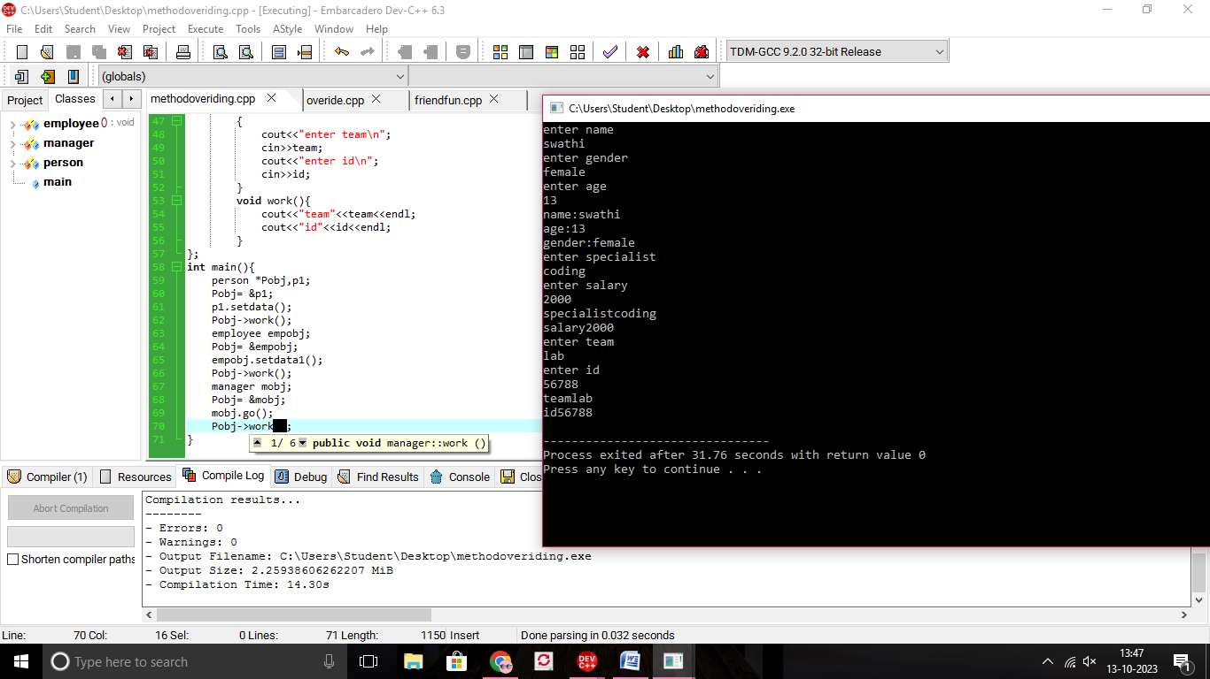

FRIEND FUNCTION:

#include<iostream>

using namespace std;

class B;

class A

{

public:

int a;

A()

{

a=10;

}

friend void add(A,B);

};

class B

{

public:

int b;

B()

{

b=10;

}

friend void add(A,B);

};

void add(A A1,B B1)

{

cout<<A1.a+B1.b;

}

int main(){

A R;

B S;

add(R,S);

return 0;

}

